Sed assignment

1. Change the name Meg to Megan

For this question I will use the sed command to replace the name Meg with Megan in the datebook. First I use sed then s to substitute. I then type a slash with the name that currently exists(Meg) that I want to replace. After the slash I type the new name (Megan) that I’m replacing it with.

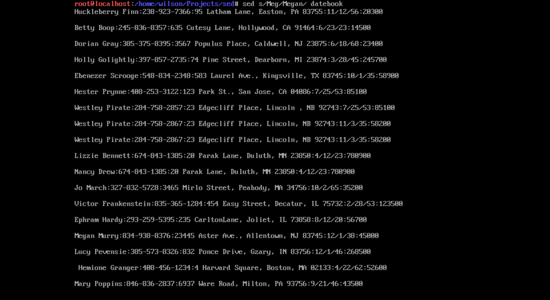

2. Delete the last 3 lines.

3. Print lines 2 through 4 .

4. Delete lines containing Place.

5. Print all lines where the birthdays are in the first week of the month. Be careful of the dates for birthdays, the format is MM/DD/YY

6. Append three asterisks to the end of lines starting with Sir

Commands used:

Sed s/Meg/Megan/ datebook

1. Delete the last 3 lines.

To delete the last 3 lines in the datebook I used the lowercase d delete command with semicolon separators. I also used $ to signify the last line.

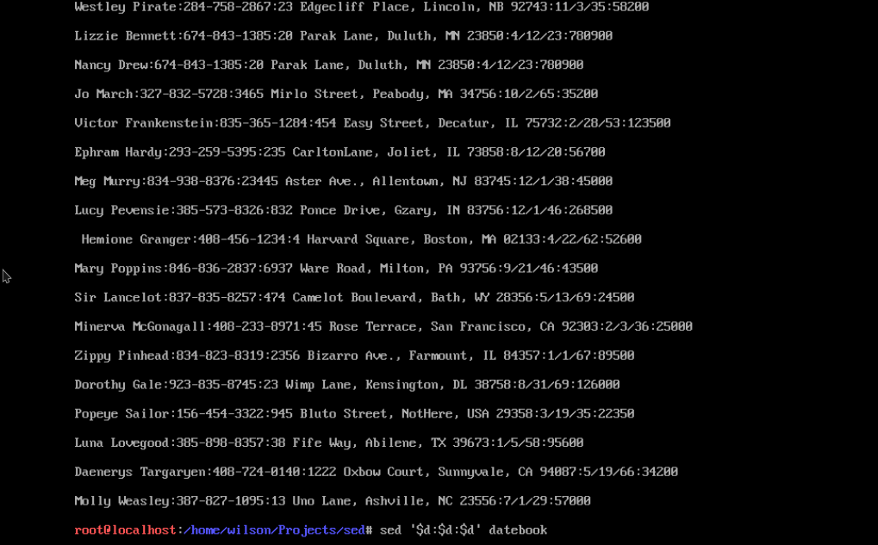

Commands used:

sed ‘$d;$d;$d’ datebook

1. Print lines 2 through 4 .

To print the lines 2 through 4 I used the sed command combined with the lowercase n parameter to suppress the automatic printing of pattern space. I then typed 2 as the starting line and comma 4 as the ending line. I also added p to print the current pattern space.

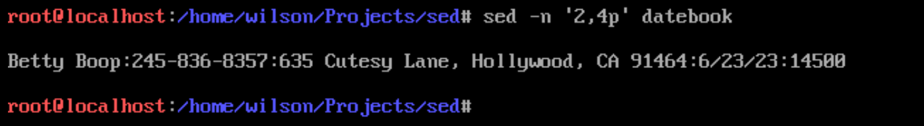

Commands used:

sed -n ‘2,4p’ datebook

1. Delete lines containing Place.

For this question I need to delete all lines containing “Place”. To do this I will use the sed command with the parameter lowercase e. I then used slash Place slash d to find all lines starting with “Place” and delete the pattern space.

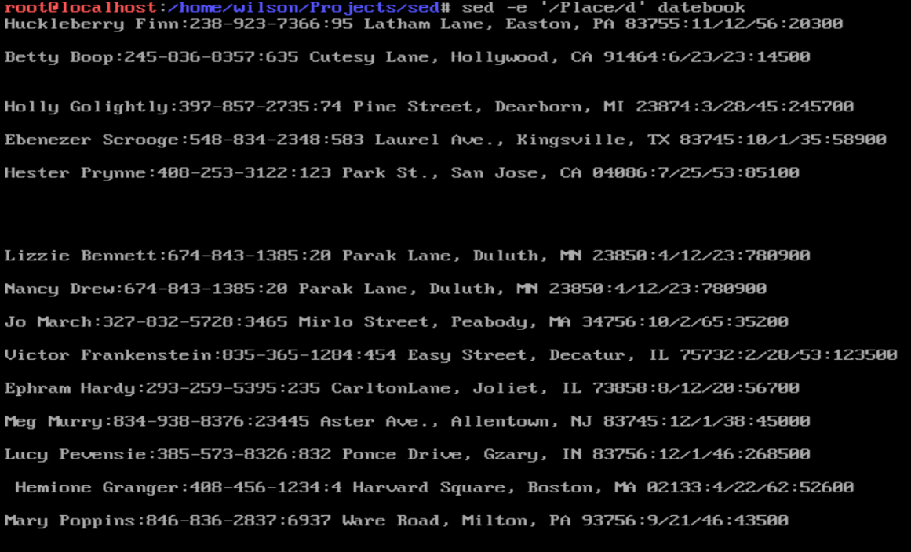

Commands Used:

sed -e ‘/Place/d’ datebook

1. Print all lines where the birthdays are in the first week of the month. Be careful of the dates for birthdays, the format is MM/DD/YY

For this question I need to only listed the birthdays which begin in the first week of the month. To do this I need to use -n and -r (regex extended) with sed. I first match 5 numbers from 0-9 and a colon. I then matched numbers [0-9] for the month in the birthday. Then I matched 1-7 for the first week of the month. I then printed the matching lines in the datebook.

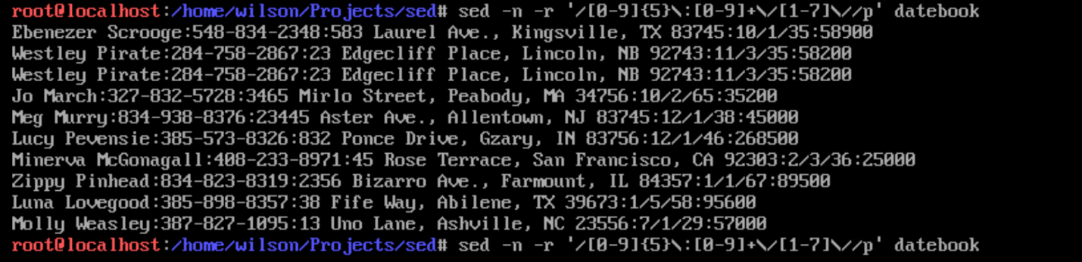

Commands Used:

sed -n -r '/[0-9]{5}\:[0-9]+\/[1-7]\//p' datebook

1. Append three asterisks to the end of lines starting with Sir

To append the lines starting with Sir I need to use sed with the lowercase -e parameter. I then enclose in single parenthesis, slash Sir slash a escape then three asterisks. The a is used to append the line Sir with the asterisks.

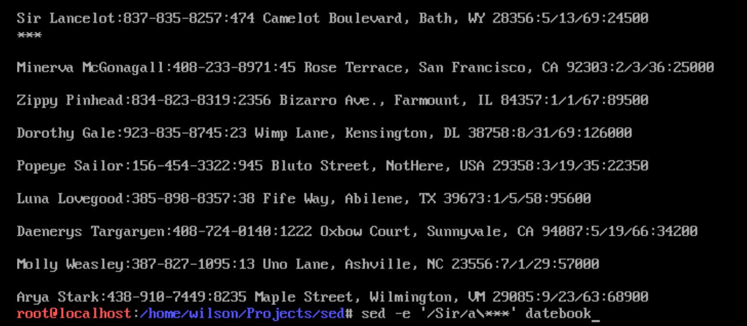

Commands used:

sed -e ‘/Sir/a\\*\*\*’ datebook

1. Replace the line containing "Westley Pirate" with the phrase "As you wish."

For this command I need to replace “Westley Pirate” With “As you wish.”. To start this I first used the sed command with the lowercase e parameter which will replace the pattern space with an output. I then used the lowercase s (substitute) to change the entire lines containing “Westley Pirate” to “As you 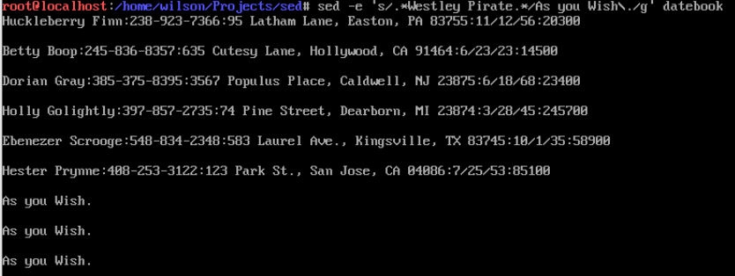wish.”

Commands used:

sed -e 's/.\*Westley Pirate.\*/As you Wish\./g' datebook

1. Change Minerva McGonagall's birthday to 12/25/1960 . Assume you don't know Minerva's original birthday. Use a regular expression to search for it.

For this question I need to identify the line with the name Minerva McGonagall and change the birthday to 12/25/1960. First I use sed with the lowercase e parameter and find the line with Minerva McGonagall. Then I use three bracketed [0-9] numbers to identify the date within the line. After this I substituted the original date with 11/14/46.

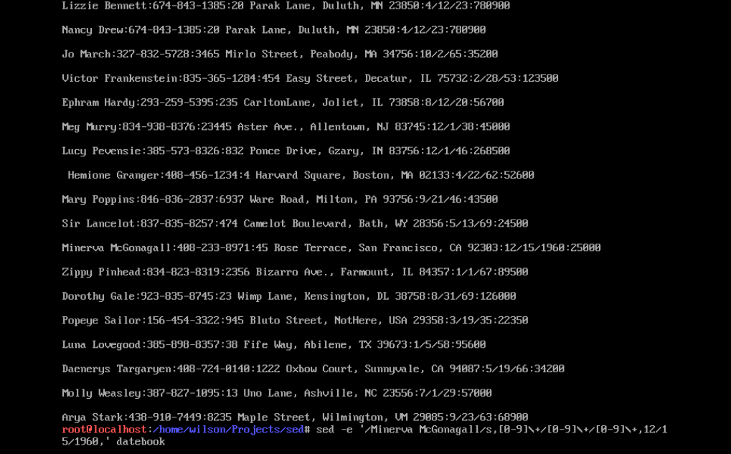

Commands used:

sed -e ‘/Minerva McGonagall/s,[0-9]\+/[0-9]\+/[0-9]\+,11/14/46,’ datebook

1. Delete all blank lines.

To delete all of the blank lines in the datebook I used single parenthesis to contain a pattern which starts with blank (using ^) and ends with blank (using $) and then use d to remove the lines within the datebook.

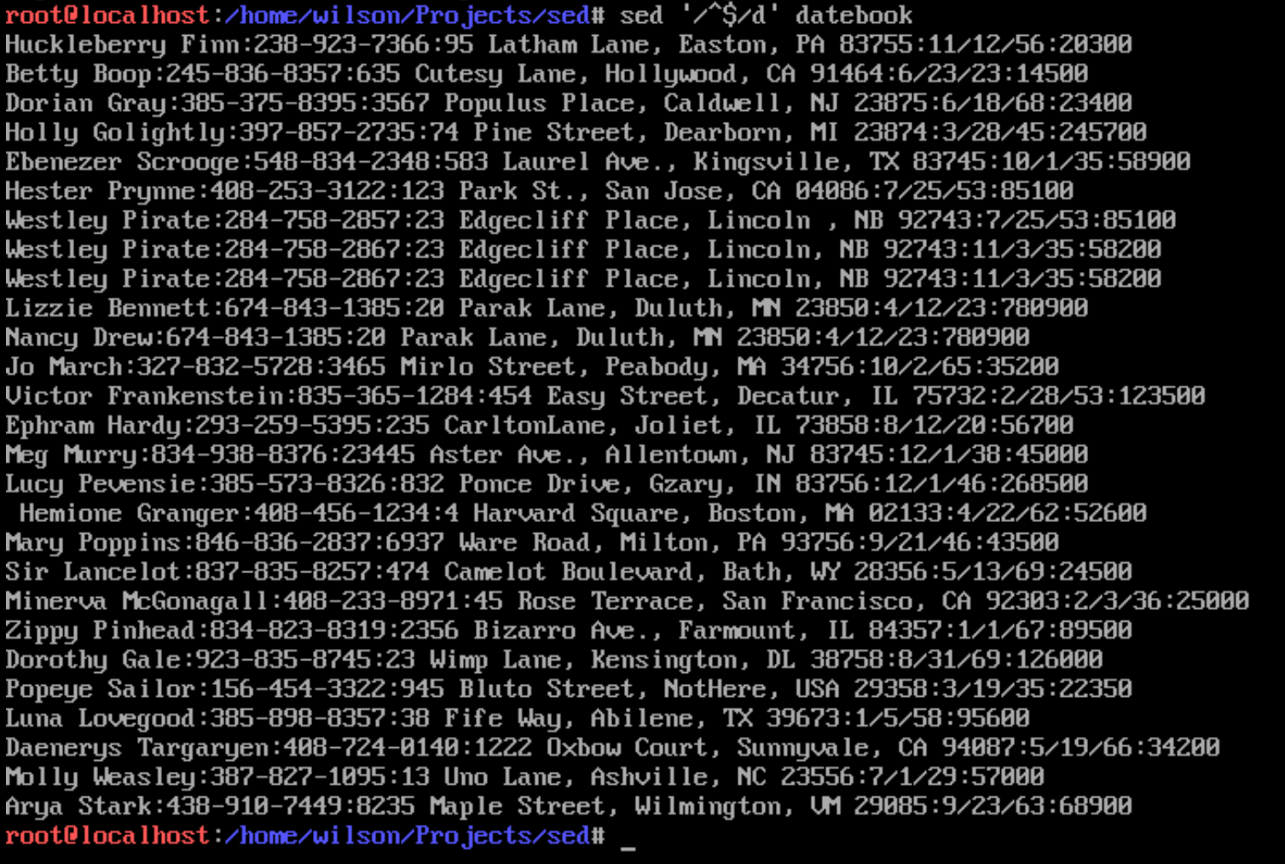

Commands used:

sed ‘/^$/d’ datebook

1. Write a sed script that will (actual sed script, NOT just the commands on the command line)

a. Insert above the first line the title - Great Literary Characters -.

b. Remove the duplicate lines

c. Print the contents of the file with the first name then the phone number.

d. Append at the end of the file "Happily Ever after. The End"

Script attached to assignment in Blackboard.

Sources used:

<https://linux.die.net/man/1/sed>

<https://flylib.com/books/en/4.356.1.50/1/>